УДК 338
UDC 338
А.Л. Зелезинский, доцент кафедры менеджмента и маркетинга, к.п.н., доцент; ФГБОУ ВО «Санкт-Петербургский государственный технологический институт (технический университет)», Санкт-Петербург
A.L. Zelezinskii, Associate Professor of the Department of Management and Marketing, PhD in pedagogics, Associate Professor; Federal State Budgetary Educational Institution of Higher Education “Saint-Petersburg State Institute of Technology (Technical University)”, Saint-Petersburg
E-mail: uchposob@yandex.ru

О.В. Архипова, профессор кафедры гостиничного и ресторанного бизнеса, д.ф.н., доцент; ФГБОУ ВО «Санкт-Петербургский государственный экономический университет», Санкт-Петербург
O.V. Arhipova, Professor of the Department of Hotel and Restaurant Business, Doctor of Philosophy, Associate Professor; Federal State Budgetary Educational Institution of Higher Education “Saint-Petersburg State University of Economics”, Saint-Petersburg
E-mail: olva@list.ru

Д.В. Ходос, профессор кафедры экономики и организации производства, д.э.н., доцент; ФГБОУ ВО «Санкт-Петербургский государственный технологический институт (технический университет)», Санкт-Петербург
D.V. Hodos, Professor of the Department of Economics and Organization of Production, Doctor of Economics, Associate Professor; Federal State Budgetary Educational Institution of Higher Education “Saint-Petersburg State Institute of Technology (Technical University)”, Saint-Petersburg
E-mail: hodos1@rambler.ru

C. К. Жуков, магистрант кафедры менеджмента и маркетинга ФГБОУ ВО “Санкт-Петербургский государственный технологический институт (технический университет)”, группа № 6101, Санкт-Петербург.
S.K. Zhukov, Master student of the Department of Management and Marketing of the St. Petersburg State Institute of Technology (Technical University)”, group № 6101, Saint-Petersburg
E-mail: Serroga.999@gmail.com

КОНКУРЕНЦИЯ И СПОСОБЫ КОНКУРЕНТНОЙ БОРЬБЫ В СРЕДЕ ЦИФРОВОЙ ТЕХНИКИ
COMPETITION AND METHODS OF COMPETITION IN THE DIGITAL TECHNOLOGY ENVIRONMENT
Аннотация. В статье исследовано понятие “конкуренция”. Рассматриваются фактические конкурентные случаи и способы конкурентной борьбы между крупнейшими компаниями – производителями цифровой техники. Авторы рассматривают конкуренцию на рынках вычислительных процессоров, смартфонов и систем домашнего развлечения. В статье приведены графики продаж конкурирующих компаний и сравнения потребительских характеристик товаров, напрямую влияющих на их конкурентоспособность.
Annotation. The article examines the concept of "competition". The actual competitive cases and ways of competition between the largest manufacturers of digital technology are considered. The author examines the competition in the markets of computing processors, smartphones and home entertainment systems. The article presents sales charts of competing companies and comparisons of consumer characteristics of goods that directly affect their competitiveness.
Ключевые слова: конкуренция, способ конкуренции, продажи, конкурентоспособность.
Keywords: competition, way of competition, sales, competitiveness.

Currently, digital technology is rightfully one of the most important types of electronic devices for humanity. A worldwide Network is spread almost all over the world - the Internet, which unites people, cities and even countries. According to the estimates of the International Telecommunication Union, 53.6% of the population on Earth regularly uses the Internet, and in developed countries this percentage reaches 86.6 % [1]. Digital technology is responsible for the development, formation and use of the Internet. Thanks to the invention and general popularization of smartphones and laptops, humanity has been able to use the Internet almost anywhere and with a high degree of comfort.
Competition, at its core, is a rivalry between companies that produce goods or services for the opportunity to find a consumer of their product in order to further sell it and make a profit. Competition is rightfully considered the most important factor in the development of the company. The very phenomenon of competition between companies forces them to study consumer requests for certain services. Below are a number of criteria that are necessary to maintain or improve competitiveness:
- timely updating of its range of goods or services that must match its price,
- product quality and novelty,
- timely price adjustment,
- continuous improvement of various customer service systems.
Also, do not forget about the analysis of the competitive advantages of your organization and competing organizations. The company will face setbacks, up to withdrawal from the market, if the company is uncompetitive for certain reasons and cannot clearly express any advantages over competitors, even if there are any.
The world's largest manufacturers of digital technology, such as Apple, Samsung, IBM, Microsoft, etc. they have been sharing a large digital technology market for decades, constantly competing with each other. If a few decades ago the digital and computer technology market was only in the initial stage of development, and such giants as Intel, IBM and Apple had much smaller scales, now there are many corporations with a turnover of tens of billions of dollars and above.
Based on the modern market and the presence of a huge number of potential and actual competitors, even the largest companies are now forced to invest in the development of innovative ways to compete for consumer attention. Consider the competition in the environment of computing and computers - most clearly on the examples of companies such as Intel and AMD, referring to Figure 1.
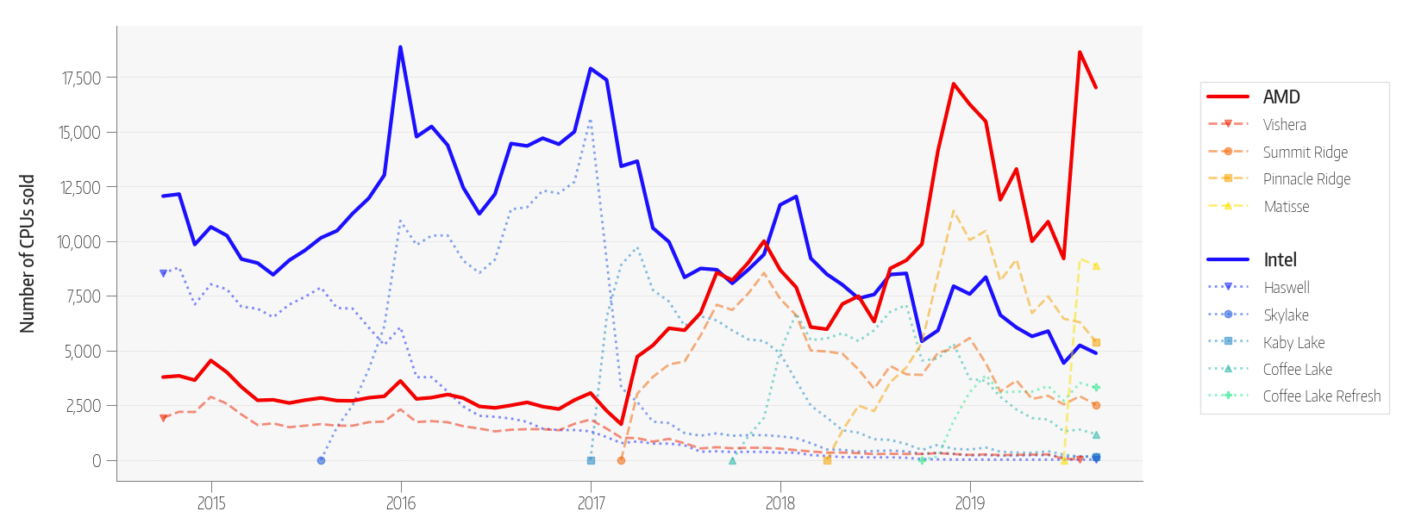 Figure 1 - Shares of Intel and AMD sales in Mindfactory sales over the past five years.
The graph provided in Figure 1 contains information about changes in the share of sales of these two processor manufacturers over the past 5 years. Intel has been a leader in processor sales for more than two decades, but the quality of improvements to their processors, as well as their level of innovation, have declined significantly during this time, up to almost complete stagnation after the release of the Sandy Bridge processor family (2011) until 2020. AMD, on the contrary, being not such a large company, produced quite highly specialized processors. As soon as it became clear that the nature of Intel's improvement of its products had become very slow, by 2017 AMD decided to invest in the enhanced development of new, innovative processors for the company and the market as a whole – AMD Ryzen. If we talk about the number of CPUs sold, AMD surpassed Intel for the first time in many years in 2017, but quickly lost its leadership. But already in 2018, with the release of the Zen+ generation, AMD sales increased significantly again, and after that the company's share has always been higher than Intel's share. Actually, with the release of Ryzen 3000 in 2019, everything became even clearer.
However, the competition between these processor manufacturers is not only at the level of quality and final product characteristics, but also at the production level. Both companies use the power of TSMC, the world's largest manufacturer of semiconductor crystals, to produce their processors. Competition begins already at the design stage, since one of the main qualities of a processor that directly affects its power and efficiency is its process technology. The technological process of semiconductor production is a technological process for the manufacture of semiconductor (n/a) products and materials; it consists of: a sequence of technological (processing, assembly) and control operations, photolithography and lithographic equipment are used in the production of n / a products. The resolution (in microns and nm) of this equipment (the so-called design standards) determines the name of the specific technological process used [2]. The processor process, in fact, means the physical size of one transistor on the processor substrate, it depends on what the CPU will have power consumption, heat generation, as well as how many transistors can fit on one substrate, which directly affects its final computing performance. Since 2016, Intel has not actually resorted to reducing the technical process of its processors, leaving it at around 14nm. While AMD, starting with the Risen line (2017), each generation reduces this indicator, and now it reaches 7 nm., which is one of the competitive advantages of their processors.
Considering one of the largest markets for electronics and digital technology today – the smartphone market, then you can see a much larger number of manufacturing companies and much more "fierce" competition.
In 2007, Apple introduced the first smartphone in the modern sense – the Apple iPhone. The device went on sale on June 29, 2007 along with the iPhone OS and quickly gained a significant part of the smartphone market in the United States. The popularity of the iPhone OS was supported by the iPod touch, which went on sale in September of the same year, which, however, had noticeably reduced functionality compared to the iPhone [3]. This smartphone was a completely new device for the market, although already at the time of release it was losing to competitors in many consumer characteristics. Apple did not immediately "conquer" the smartphone market, as competition from manufacturers more familiar to consumers - Nokia, Samsung, Siemens, etc. was too great.
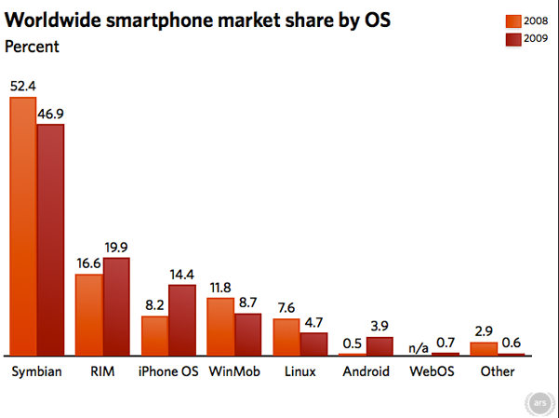
Figure 2 - Market share of smartphone operating systems in the world in 2008-2009
Analyzing the graph shown in Figure 2, we can conclude that even 2 years after the release of such an innovative smartphone as the iPhone, the company's market share was much inferior to other companies. The main share was occupied by Nokia (OS Symbian) and BlackBerry (RIM).
There is a paradox that Apple iPhone smartphones, which by 2011 (iPhone 4S) had become the absolute market flagships in technical terms, did not increase their smartphone market share above 7% in total sales. In turn, in 2017, at the time of the release of the iPhone 8 and iPhone X, these smartphones, as a rule, were significantly inferior to competitors in terms of characteristics, but the total market share increased to 11%.
It was this year that Apple began to use a special way of competition, which is marketing based on imaginary innovations and huge consumer loyalty to the company. The iPhone X released at that time, on the ”revolutionary" of which Apple was betting, was inferior to competitors in the face of Samsung Galaxy S8, Pixel 2/2XL, HTC U11+ in a whole range of consumer characteristics, such as: screen resolution, stereo speaker volume, data transfer rate and display brightness. However, the average consumer preferred the iPhone, thanks to Apple's successful marketing policy.
At the stage of production and patents in the same 2017, when developing the iPhone X, Apple also applied another tool of competition, such as patents. When developing the shape and dimensions of the iPhone X case and display, a far from new, but previously patented technology of “wrapping” a flexible OLED display around the edges of the smartphone inside the frame was used, thanks to which it was possible to make the narrowest and only symmetrical frames around the screen on the market. Until now, due to this Apple patent, other smartphone manufacturers cannot use this screen manufacturing technology in their smartphones, and are forced to invest tens of millions of dollars in the development of new or similar technologies.
The current sales trend of Apple, in essence, contradicts the fact that the highest quality and cheapest goods are sold best. At the end of 2020, Apple became the main headliner of growth, doubling sales volumes (to 90.1 million units) relative to the third quarter due to the iPhone 12 series and soaring due to this from the fourth line of the rating to the first, taking 23.4% of the market. It was followed by Samsung with 73.9 million shipped devices (19.1% of the market), and Xiaomi closes the top three with 43.3 million smartphones sold and a market share of 11.2%. Last but not least, its success is associated with a huge decrease in Huawei shipments by 42.4% and a reduction in its market share to 8.4%, analysts says [4].
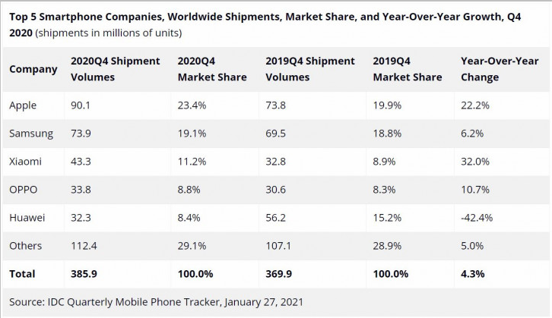Figure 3 - Top 5 smartphone manufacturing companies by sales and occupied market shares in 2019-2020.
Based on the data presented in the figure, it can be concluded that Apple products are becoming more popular every year. Moreover, this popularity is not due to the optimal price of the product, but to the extremely successful competition policy from Apple. Paradoxically, in 2021, according to Counterpoint Research, the most popular smartphones are the iPhone 12, iPhone 12 Pro Max and iPhone 11, although they have the highest cost of all available flagship smartphones on the market and presented in the study, in particular.
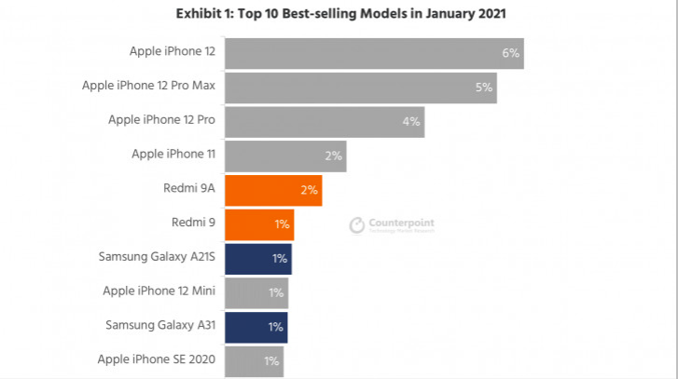
Figure 4. Top 10 best-selling smartphone models in the world in January 2021 [5].
When directly comparing the consumer characteristics of Apple smartphones with manufacturers such as Samsung, Xiaomi or Oneplus, we can say that their products are absolutely outdated in moral and technological terms for 2-3 years, which is a huge period for the modern smartphone market.

Table 1 - Comparative analysis of the iPhone 12 Pro Max smartphone with its competitors
Specifications | iPhone 12 Pro Max | Samsung Galaxy S21 Ultra | Xiaomi Mi 11
Date of market launch | 2020 | 2020 | 2020
Retail price in Russia, roubles | 105980 | 92900 | 69990
OS | IOS | Android | Android
The version of the operating system at the time of release | IOS 14 | Android 11 R | Android 11 R
Screen Size | 6.7" | 6.8" | 6.81"
Screen resolution | 1284x2778 | 1440x3200 | 1440x3200
RAM | 4 GB | 12 GB | 8 GB
Support for multiple SIM cards | 1 | 2 | 2
Number of cameras | 4 | 5 | 4
Number of matrix points of the main camera | 12 megapixels | 108 megapixels | 108 megapixels
CPU | Apple A14 Bionic | Exynos 2100/Snapdragon 888 | Snapdragon 888
CPU clock speed | 2 450 MHz | 2 840 MHz | 2 840 MHz
Dimensions (WxHxT) | 78.1 х 160.8 х 7.4 mm | 75.6 х 165.1 х 8.9 mm | 74.6x164.3x8.06 mm
Screen manufacturing technology | OLED | Dynamic AMOLED 2X, 120 Hz | AMOLED, 120 Hz
Number of pixels per inch | 458 ppi | 515 ppi | 515 ppi
Maximum video resolution | 3840 x 2160 | 7680 x 4320 | 7680 x 4320
Front camera | 12 Mp | 40 Mp | 20 Mp
Battery capacity | 3 687 mAh | 5 000 mAh | 4 600 mAh
In terms of characteristics, the smartphone analyzed in Table 1 is significantly inferior to its direct competitors from Samsung and Xiaomi. This is especially observed in the points “Number of matrix points of the main camera” and “Battery capacity”.
It is also possible to analyze the competitiveness of Apple smartphones with others through the most important innovation and innovation of the most modern phones - the installation of screens with an increased screen refresh rate. The refresh rate of the screen shows how fast the image changes on it. It tells you how much such iteration occurs every second, and is measured in Hertz (Hz). The picture on the display with a refresh rate of 60 Hz changes 60 times per second, 90 Hz says about changing the image 90 times per second, and 120 Hz is 120 iterations for the same period of time. The screen with a refresh rate of 120 Hz in a modern flagship smartphone changes the image on the screen twice as fast as the usual display at 60 Hz. Smartphones that use screens with a refresh rate of 90 Hz or 120 Hz show any moving content more smoothly. The value of increasing the frequency increases when it comes to a much larger number of dynamic graphic elements on the screen [6].
The first smartphone with a non-standard refresh rate was the Sharp Aquos Zeta SH-01H with 120 Hz, which appeared in the winter of 2015. A few years later, by 2020, almost all Android flagships are equipped with screens with a similar refresh rate, which can be seen on the example of two smartphones in Table 1. However, Apple flagships were deprived of such an innovative feature until the fall of 2021, which is again paradoxical. In September 2021, Apple presented its new flagship iPhone 13 Pro/Pro Max, where the company presented its flagship display with a screen refresh rate of 120 Hz - as something revolutionary. However, this way of competing after 2017 and the release of the iPhone X has lost its effectiveness greatly, and this innovation was taken for granted.

Competition in the digital technology environment can also be considered in the market of home entertainment systems, namely, game consoles. The time period under consideration is the second half of the eighth generation of game consoles, March 2017 - January 2020. Sony's console, the PlayStation 4, significantly dominates sales over its direct competitor, the Xbox One. In Figure 5, you can clearly see the gap in the number of sales of these two products
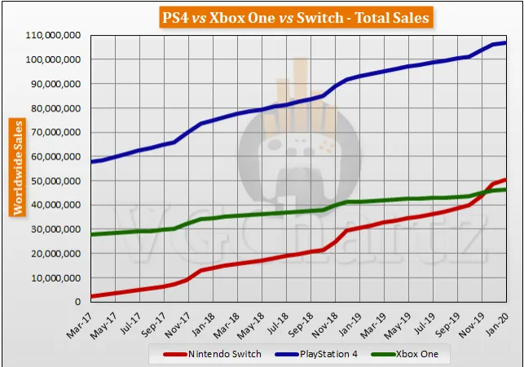
Figure 5. Total sales of Xbox One, PlayStation 4 and Switch for 2017-2020 [7].
There are several reasons for a significant gap. The very first reason for the final uncompetitiveness of the Xbox One, oddly enough, appeared even before the start of console sales. At its presentation in May 2013, Microsoft provided several key positions regarding the console, which negatively affected the consumer's desire to purchase it:
- Xbox One will require a permanent Internet connection;
- Xbox One will not play used discs (it will not be possible to resell the disc to someone or even give it to a friend to play);
- The Xbox One will only come with a Kinect sensor (which is practically useless)•
- The Xbox One will cost $500 — $100 more expensive than the PS4.
Immediately after this presentation, Microsoft's shares fell, but Sony's soared. Interestingly, later (even before the console was released), the company abandoned all of the above points, however, the potential consumer still had a negative impression of the product. While Sony, in the same year, actually showed nothing of interest to the buyer. They showed exclusive games, but did not say when these games will be released at all. As a result, it turned out this way — Microsoft "stipulated" themselves, while Sony did not have to take special measures. A lot of people were sure that there would be nothing to play on Xbox One, although the situation was rather the opposite, because Sony showed these very trailers of games from time to time, but before the release of Uncharted 4 there was nothing really loud on PS4 [8].
The second reason for the lack of competitiveness of the console from Microsoft is the insufficiently innovative hardware. Xbox One was inferior to Sony's competitor in computing power – the main characteristic of the device, whose task is to launch large-scale and detailed three-dimensional projects. Figure 6 shows the main technical characteristics and differences between the two competitors.
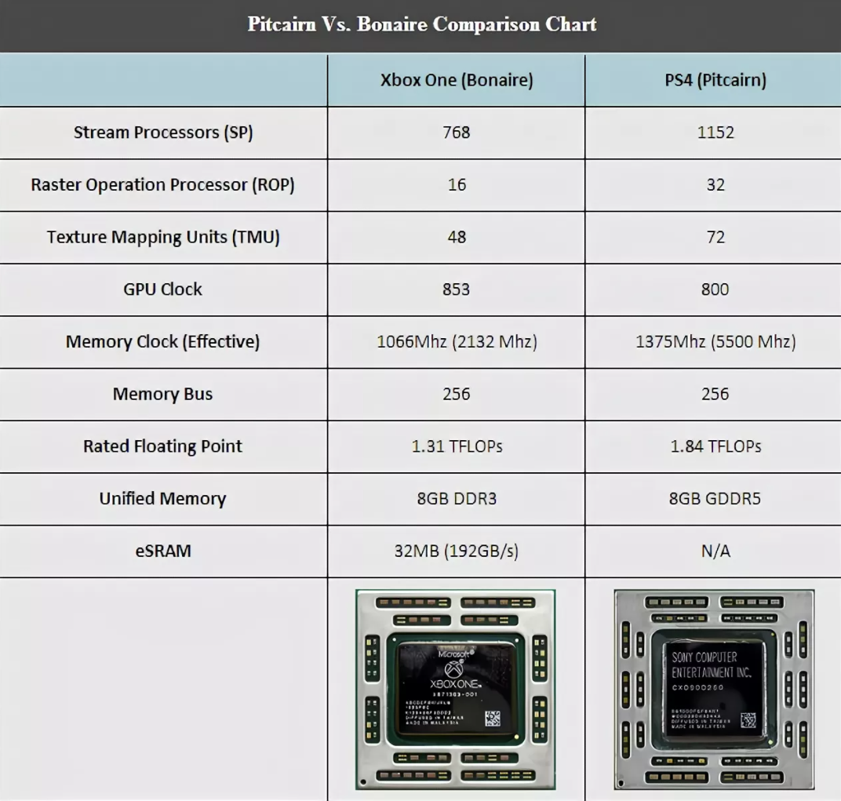
Figure 6. Comparison of the main technical characteristics of Xbox One and PlayStation 4.
The most important points of comparison presented in Figure 6 - Rated Floating Point and Unified Memory clearly demonstrate the superiority of the Sony console.
However, there is another reason for the success of the PS4 against the background of the Xbox - the policy of "exclusives". In fact, this is a way of competition, which consists in special contracts between Sony and game manufacturers, so that they release certain "titles" only on PS4. Among such "exclusive" projects: Days Gone, Infamous: Second Son, Until Dawn, Nioh, God Of War (2018) and many others. The use of such contracts with game-making studios significantly tilts the consumer's "cup of choice" towards Sony, since large-scale and interesting projects are released exclusively for PS4, which simply cannot be purchased with an Xbox.
Generalizing, if we consider the situation in the digital technology market as a whole, companies use an extensive number of different ways to compete. Analyzing the market from three different positions, we can conclude that depending on the type of products produced (CPU, smartphones, etc.), methods of increasing its competitiveness also depend. For computing processors, this is usually an increase in energy efficiency and productivity by improving production processes and technologies. Smartphones have a much more comprehensive approach, consisting in competition and at the stage of production, patents, software development and aggressive marketing. In the home entertainment market through the competition of two ”giants" PS4 and Xbox One, it can be concluded that such methods as the conclusion of contracts for the exclusive supply of products exclusively for one company are also used to excel over a competitor.
References
- Список стран по числу пользователей Интернета. URL: https://ru.wikipedia.org/wiki/Список_стран_по_числу_пользователей_Интернета (дата обращения: 21.09.2021);
- Технологический процесс в электронной промышленности. URL: https://ru.wikipedia.org/wiki/Технологический_процесс_в_электронной_промышленности#Техпроцессы_после_середины_1990-х
(дата обращения: 21.09.2021);
- Wikipedia, Apple iPhone. URL: https://ru.wikipedia.org/wiki/IPhone
(дата обращения: 21.09.2021);
- Закат Huawei: итоговая статистика рынка смартфонов за 2020 год. URL: https://mobiltelefon.ru/post_1611815943.html
(дата обращения: 22.09.2021);
- 6 из 10 самых популярных моделей смартфонов в мире – iPhone. URL: https://mobiltelefon.ru/post_1617991718.html (дата обращения: 26.09.2021);
- Частота обновления экрана: чем отличаются 60 гц, 90 гц и 120 Гц. URL: https://trashbox.ru/link/what-is-refresh-rate-displays
(дата обращения: 24.09.2021);
- В январе 2020 консолей Switch было продано больше, чем PS4 и Xbox One вместе взятых. URL: https://www.playground.ru/misc/news/v_yanvare_2020_konsolej_switch_bylo_prodano_bolshe_chem_ps4_i_xbox_one_vmeste_vzyatyh-710563
(дата обращения: 26.09.2021);
- Почему провалился Xbox Oneю URL: https://www.ferra.ru/review/games/xbox-one-epic-fail.htm
(дата обращения: 26.09.2021);

